**ASSIGNMENT 5.5:**

**COMMANDS:**

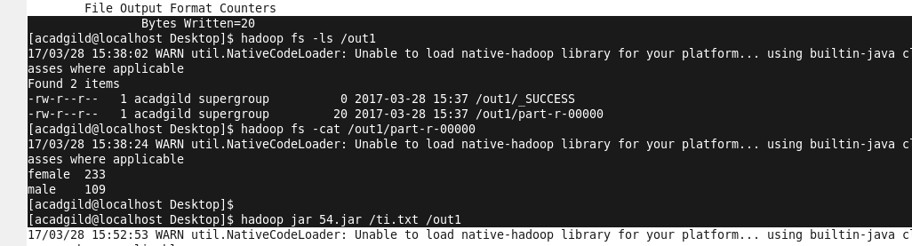

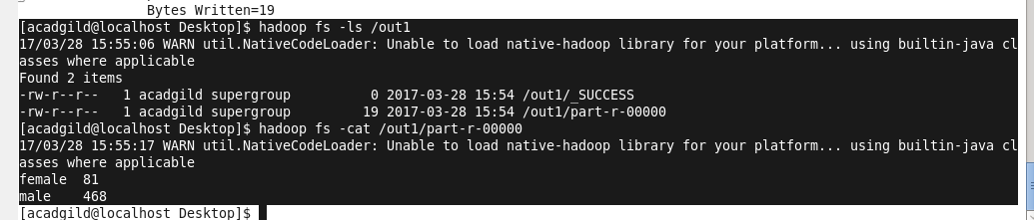

**DRIVER:**

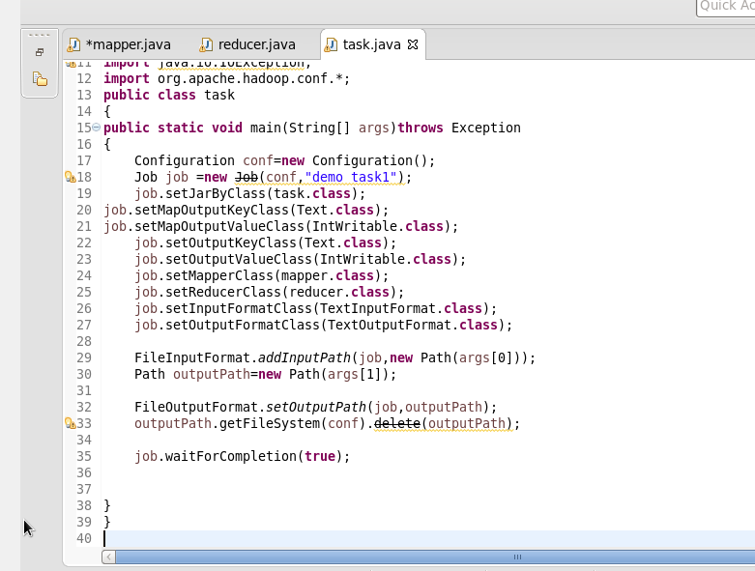

**MAPPER:**

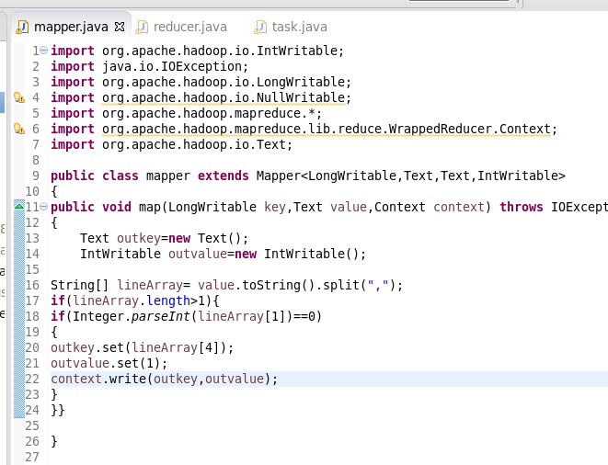

**REDUCER:**

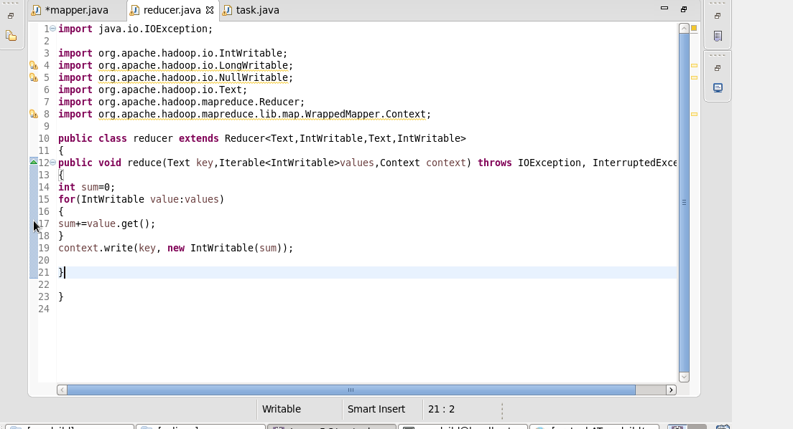

**OUTPUT:**